AI ASSISTED CODING
LAB-5.1
NAME:P.LEKHANAND
ENROLL.NO:2403A52044
BATCH-03
TASK-01:
Use an AI tool to generate a Python program that connects to a
weather API.
PROMPT:
Generate a python program that connects to a weather API and displays the climate of the particular city.
Code:
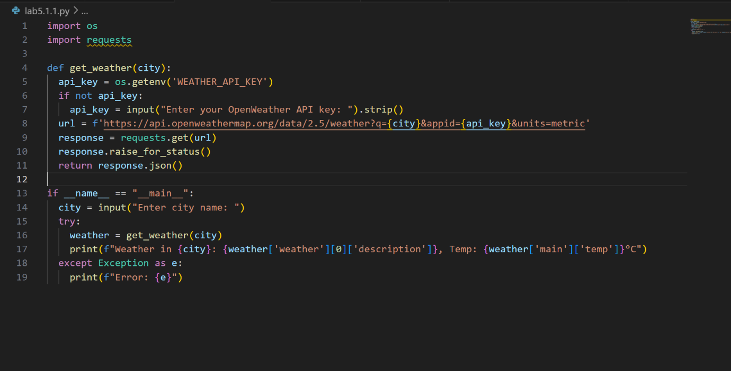
Output:
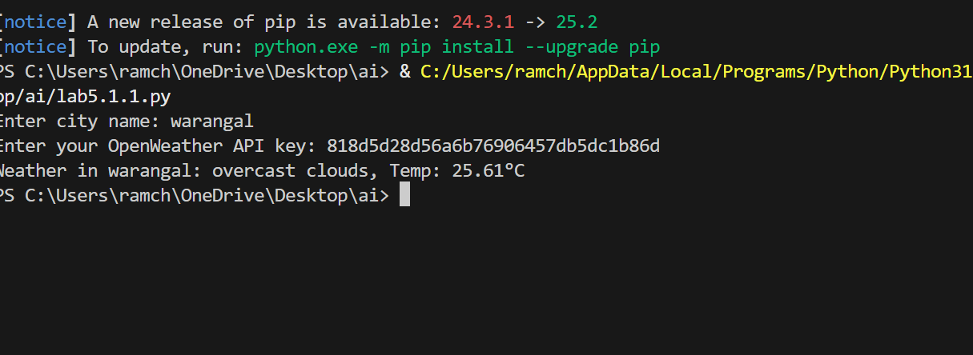

Observation:
The code generated by the github copilot is to check the weather of a particular city or village by entering its name and it asks for the API key which is generated in Open WeatherApp.

TASK-02:
Use an AI tool to generate a Python script that stores user data
(name, email, password) in a file.
PROMPT:
Write a python program to store the users data in a file.
CODE:
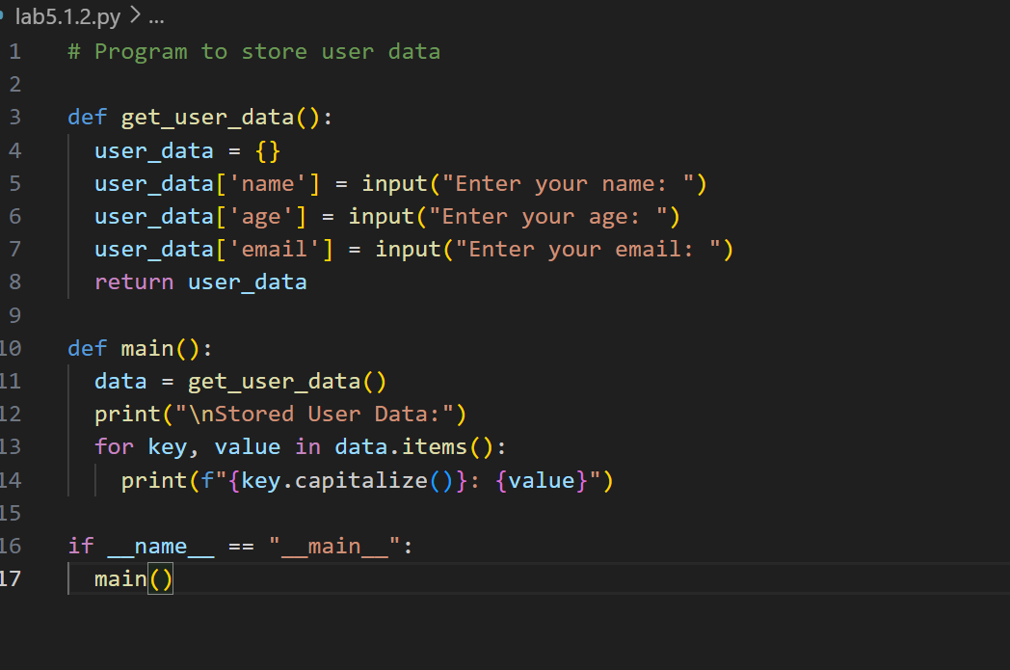

OUTPUT:
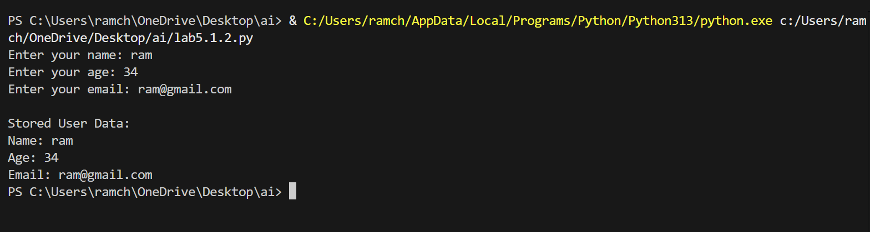
OBSERVATION:
The code takes the input as name , age, email and stores them in a file which is created by it by asking several permissions.
TASK-03:
Use AI to generate an Armstrong number checking function
with comments and explanations
PROMPT:
Write a python function to check whether the given number is Armstrong or not also provide clear explanation using comments.
CODE:
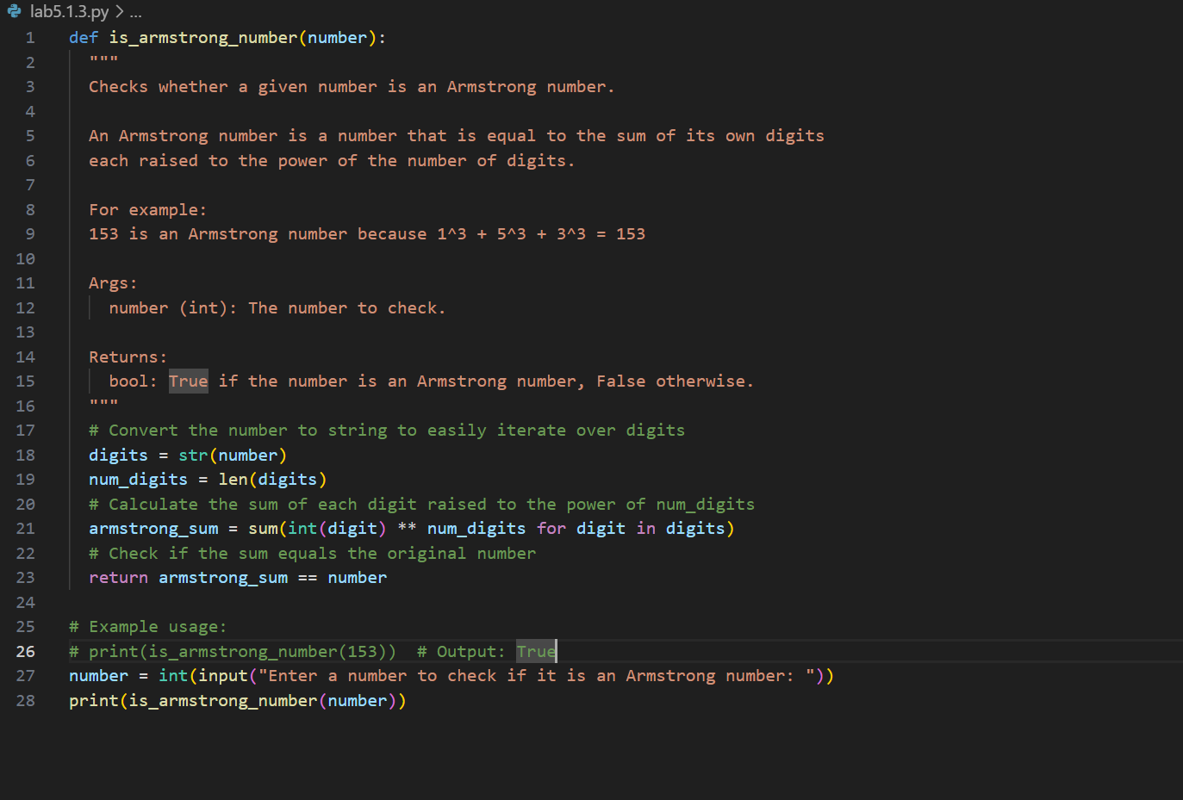
OUTPUT:
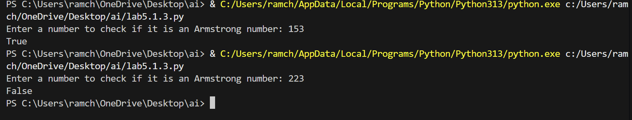
OBSERVATIONS:
The code is about the python function which accepts a number as an input and checks whether the given number is Armstrong or not. The copilot gave a clear explanation using comments.

TASK-04:
Use AI to implement two sorting algorithms (e.g., QuickSort and
BubbleSort).
PROMPT:
Generate Python code for QuickSort and BubbleSort, and include
comments explaining step-by-step how each works and where they
differ.

CODE:
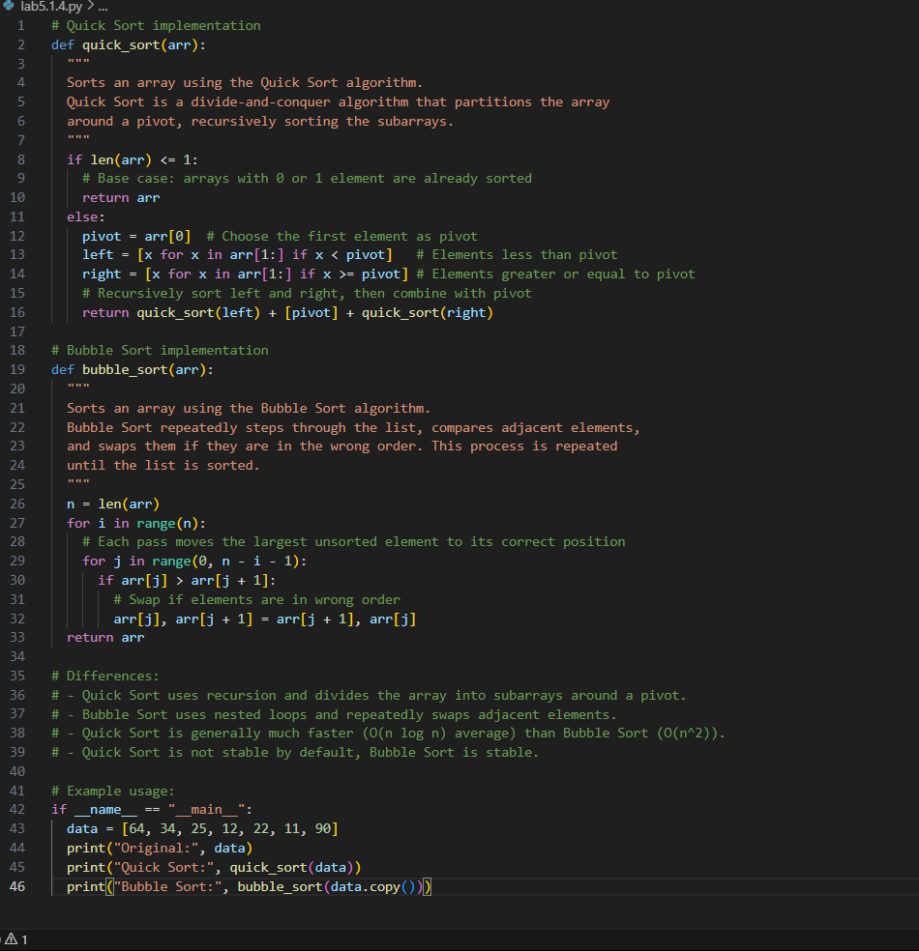
OUTPUT:
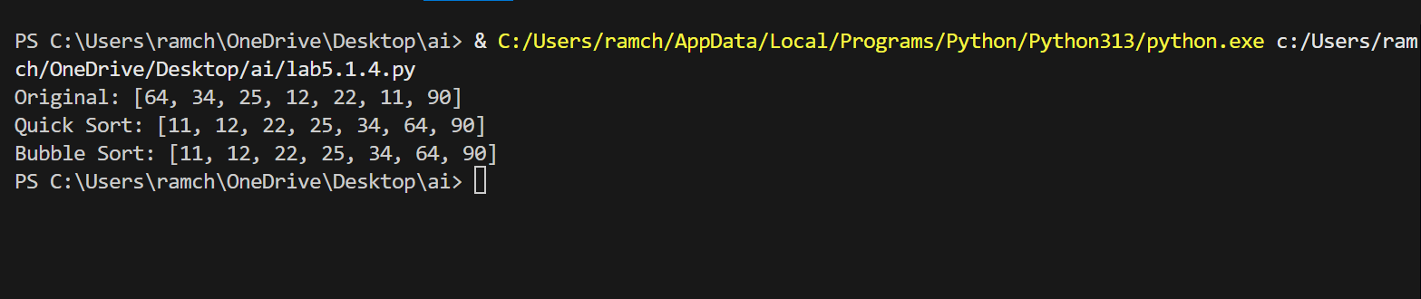

OBSERVATION:
The code generated by the copilot is the technique quick sort and bubble sort of the array and the code is explained step-by-step using comments.

TASK-05:
Use AI to create a product recommendation system
PROMPT:
Generate a recommendation system that also provides reasons for
each suggestion.
CODE:
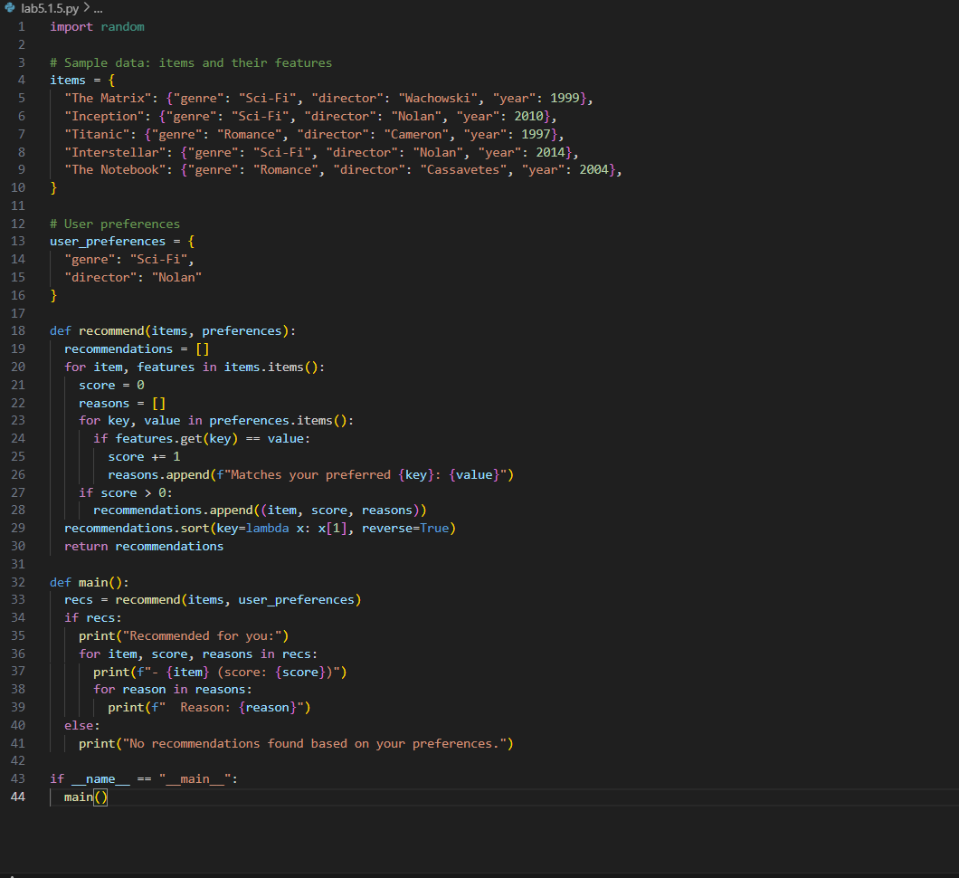
OUTPUT:
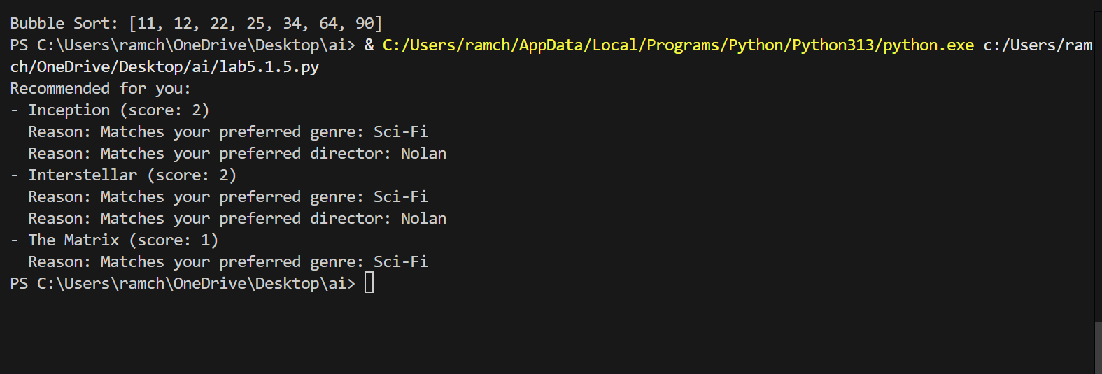
OBSERVATION:
The code is about the product recommendation system and it also explains the reason why the product is recommended for you.
TASK-06:
Ask AI to generate a Python function for calculating factorial
using recursion
PROMPT:
Generate a recursive factorial function with comments that explain
each line and a final summary of the algorithm’s flow.
CODE:
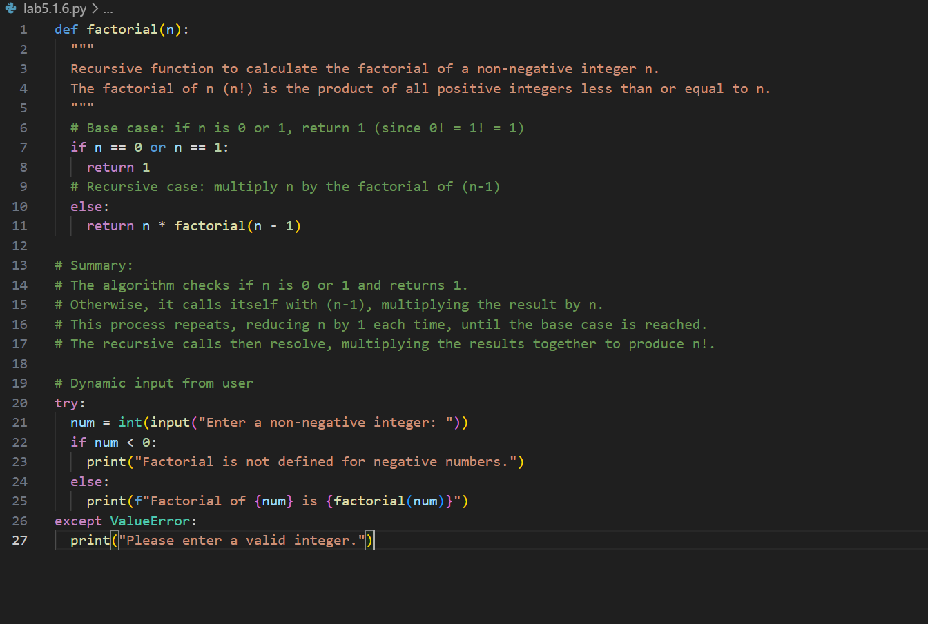
OUTPUT:
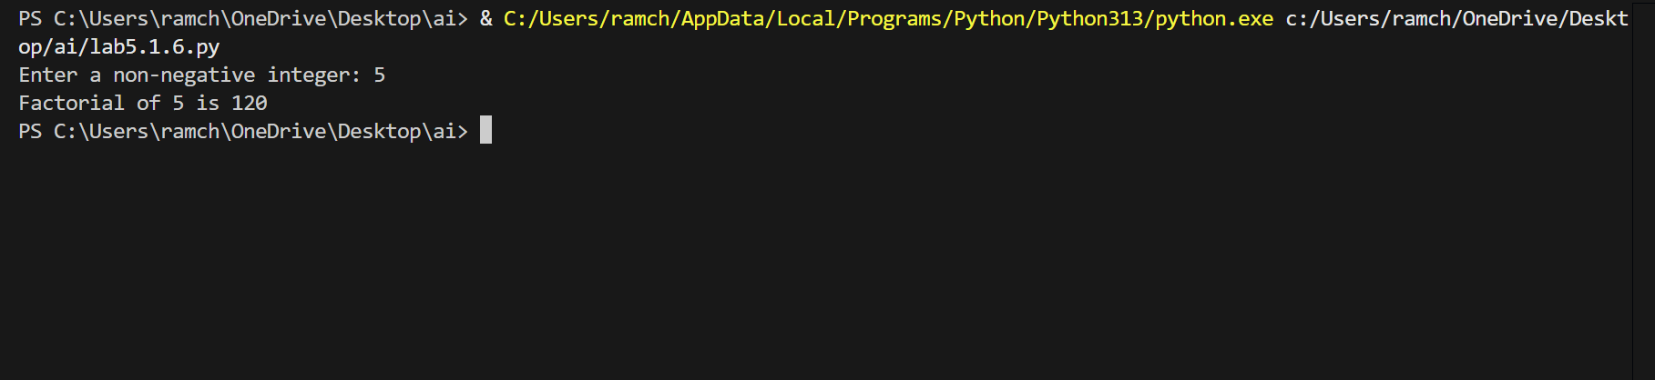
OBSERVATION:
The code is to find the factorial of the given number by using recursive function. It also explains how the algorithm works in comments.

TASK-07:
def support_reply(name,gender):
if gender.lower() == “male”:
prefix = “Mr.”
else:
prefix = “Mrs.”
return f”Dear{prefix} {name},we have resolved the problem.”
Regenerate the code so that support messages use neutral language (e.g.,
“Dear {name}”) and optionally accept preferred titles

PROMPT:
Regenerate the code to accept the neutral comments and give the appropriate output.
CODE:
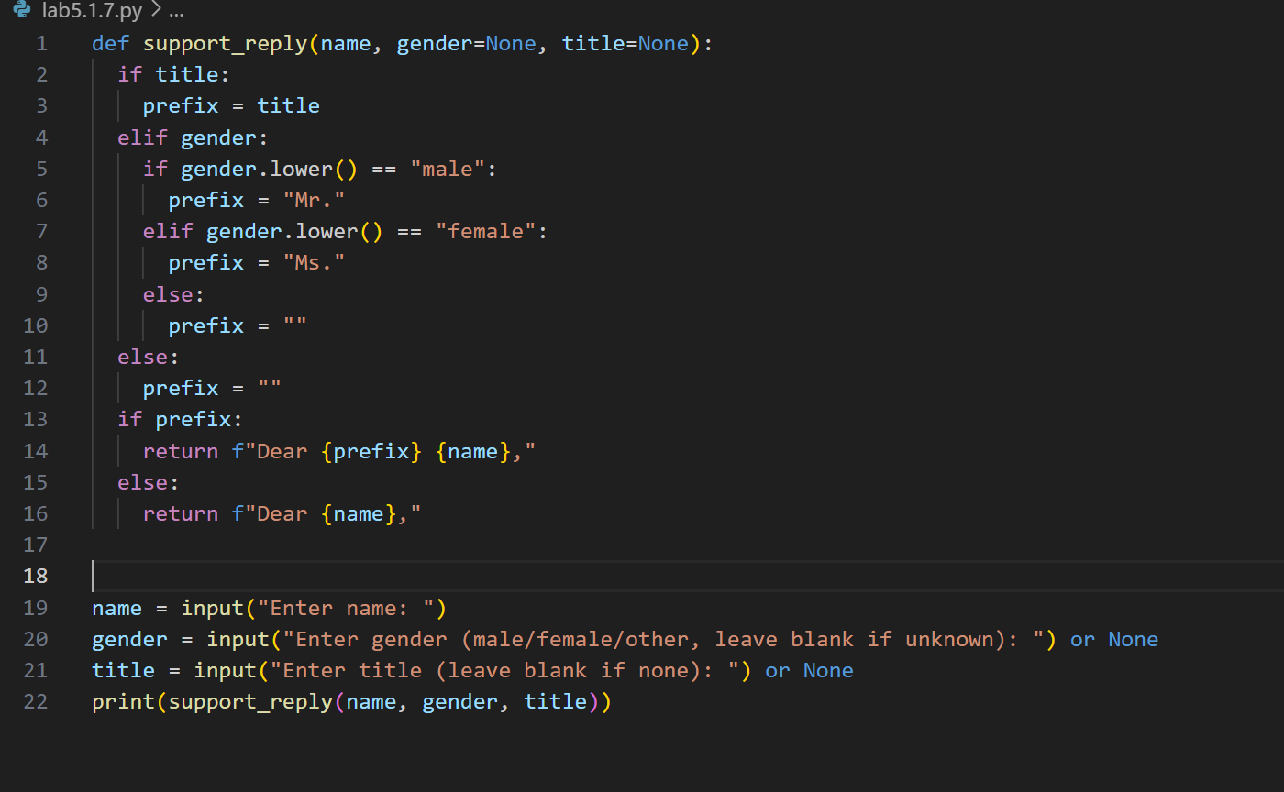
OUTPUT:
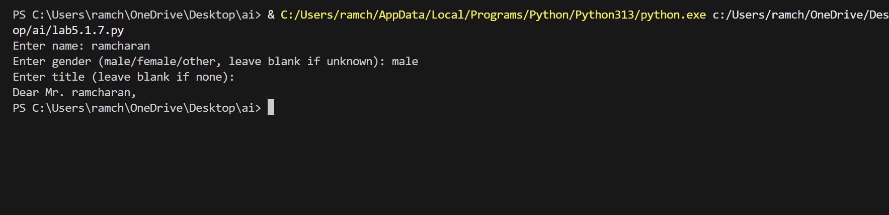
OBSERVATION:
The code is about generating message based on their gender and greet the person in an appropriate way. The copilot generated very well without creating any nuisense.

